|  |  |
| --- | --- |
| **NAME** | ARUNKUMAR G |
| **REGISTERNUMBER** | 812620104012 |
| **NMID** | A62E4CEAB5E0503803141EABB4BD21E7 |
| **ASSIGNMENT-3** | |

|  |  |  |  |
| --- | --- | --- | --- |
| **Tasks** | **1.** | **Downloadthedataset:Dataset** | |
| **2.** | **Loadthedataset.** | |
| **3.** | **PerformtheBelowVisualizations.** | |
|  | **●** | **UnivariateAnalysis** |
|  | * **Bi-VariateAnalysis** | |
|  |  | **MultivariateAnalysis** |
| **4.** | **Performdescriptivestatisticsonthe dataset.** | |
| **5.** | **HandletheMissingvalues.** | |

1. **Downloadthedataset.**
2. **Loadthedataset.**
3. **PerformtheBelowVisualizations.**

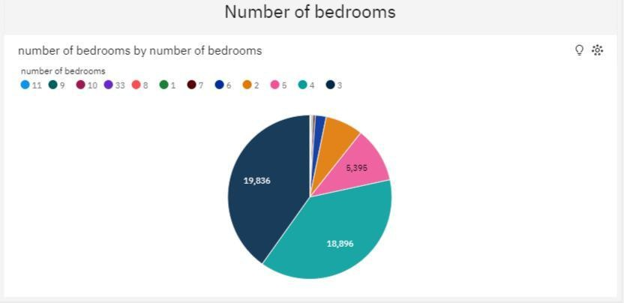UnivariateAnalysis

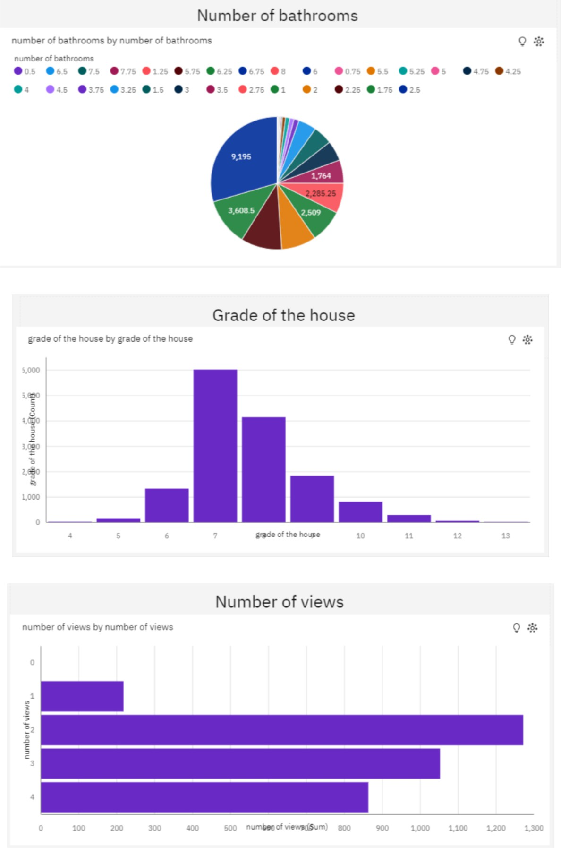

**Bi-Variate Analysis**

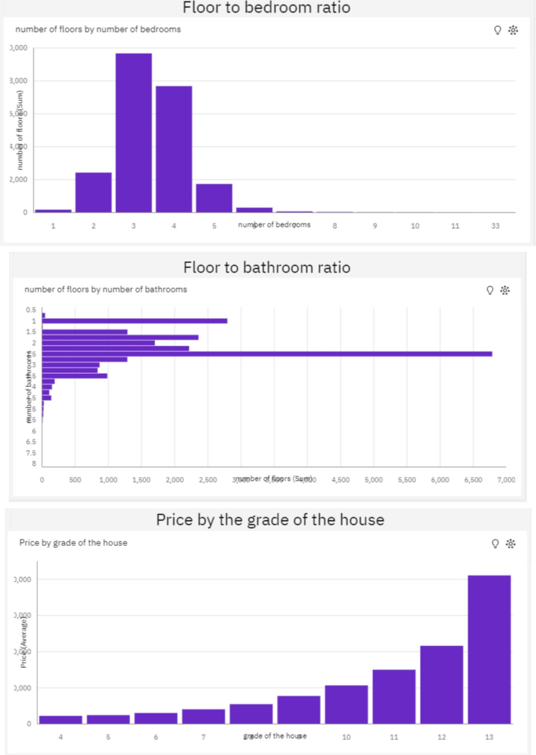

**MultivariateAnalysis**

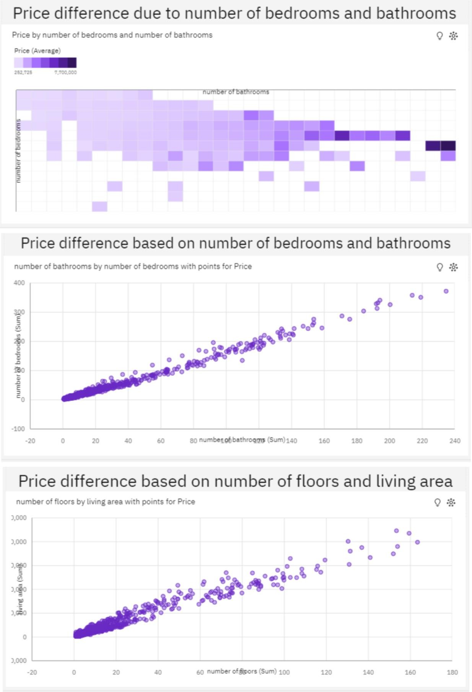

1. 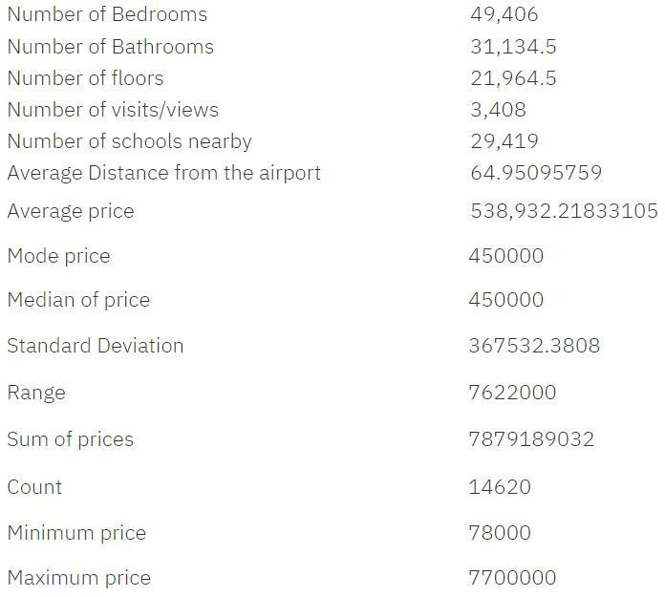**Performdescriptivestatisticsonthedataset.**
2. **HandletheMissingvalues.**

Nomissingvalues inthedataset.